

**DATA COMMUNICATION AND NETWORKING-II**

**(Project)**

**COURSE CODE: 512**

**SEMESTER: 6TH**

**BSCS-III**

**SUBMITTING TO: MA’AM ATTIYA AGHA**

|  |  |
| --- | --- |
| **NAME** | **SEAT #** |
| Isbah Ansari | B21110006049 |
| Neha Noor | B21110006101 |
| Shaikh Muhammad Bilal | B21110006119 |
| Muhammad Daniyal Khan | B21110006070 |

Computer Science Department

University Of Karachi

# Project Title: Configuring a Small Enterprise Network

## Objective

Design and configure a small enterprise network using Cisco Packet Tracer. The network should include multiple VLANs, routing between VLANs, DHCP, and basic security using Access Control Lists (ACLs).

## Requirements

### 1. Network Layout:

* 3 departments (Sales, HR, IT) connected via a switch.
* Separate VLANs for each department.
* A router for inter-VLAN routing.
* DHCP configuration for automatic IP addressing.
* Implement a wireless network for guest access.

### 2. Devices:

* PCs (4 per department)
* Switches (Layer 2)
* Router (Layer 3)
* Access Point (Wireless)
* DHCP Server
* DNS Server (optional)

### 3. VLAN Configuration:

* VLAN 10: Sales Department
* VLAN 20: HR Department
* VLAN 30: IT Department
  + Ensure that each department is on a separate VLAN with proper IP addressing.

### 4. Inter-VLAN Routing:

* + Configure routing on the Layer 3 router to allow communication between VLANs.

### 5. DHCP:

* + Set up a DHCP server to assign IP addresses dynamically to each department.
  + Ensure each department gets addresses from different subnets.

### 6. Access Control Lists (ACLs):

* Implement an ACL to block HR VLAN from accessing IT VLAN resources.
* Allow Sales VLAN to access only specific services (e.g., HTTP) on the IT VLAN.

### 7. Wireless Setup:

* Configure an access point for guest users.
* Use WPA2 security for the wireless network

## Steps

### 1. Network Design:

* Start by placing devices (PCs, switches, routers, access points) in Packet Tracer.
* Interconnect them using appropriate cabling.

### 2. VLAN Configuration:

* On the switches, create VLANs for each department and assign respective PCs to their VLANs.
* Configure trunk links between switches and the router for VLAN tagging.

### 3. Inter-VLAN Routing:

* Enable inter-VLAN routing on the router by creating sub-interfaces for each VLAN.
* Assign IP addresses to these sub-interfaces from their respective subnets.

### 4. DHCP Setup:

* Configure the DHCP server with pools of IP addresses for each VLAN.
* Ensure that each department gets IP addresses automatically from the correct pool.

### 5. ACL Setup:

* Apply ACLs on the router to control traffic flow between VLANs.
* Block unauthorized access based on the requirements.

### 6. Wireless Network Configuration:

* Set up a wireless access point with SSID and WPA2 security for guest users.
* Test wireless connectivity by adding wireless PCs to the simulation.

## Deliverables

* A Packet Tracer file containing the configured network.
* Documentation detailing the network design, configurations, and ACL rules.
* Screenshots showing VLAN, IP addressing, and routing verification using the ping command.

## Grading Criteria:

* Correct VLAN configuration and segmentation.
* Proper inter-VLAN routing setup.
* DHCP correctly assigning IPs.
* ACLs applied and functioning as expected.
* Wireless network configuration with working security.

# Project: Configuring A Small Enterprise Network

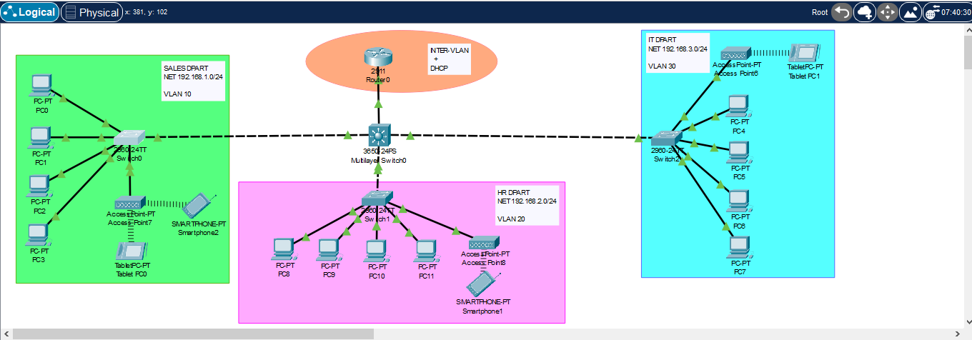

## Place Devices:

* Added 12 PCs (4 for Sales, 4 for HR, and 4 for IT).
* Added 3 2960-switches for connecting each department.
* Added 1 3560-multilayer-switch for connecting all three switches and router.
* Added 1 router (2911) for inter-VLAN routing.
* Added 1 access point (Access-Point-PT) for wireless guest access.

## Connections:

* Connect each PC to the appropriate switch using copper straight-through cables.
* Connect each switch to the multilayer switch using copper cross-over cables.
* Connect the access point to one of the switches using a copper straight-through cable.

## VLAN Configuration:

1. Creating VLAN

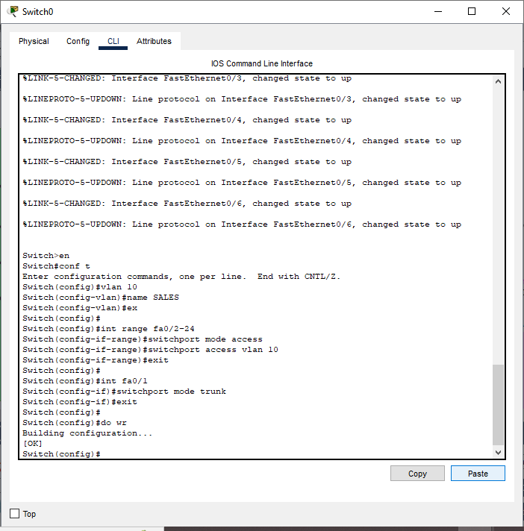

1. Assigning VLAN



1. Trunking Between Multilayer Switch and Switches



1. Create Sub-Interfaces on the Multilayer Switch

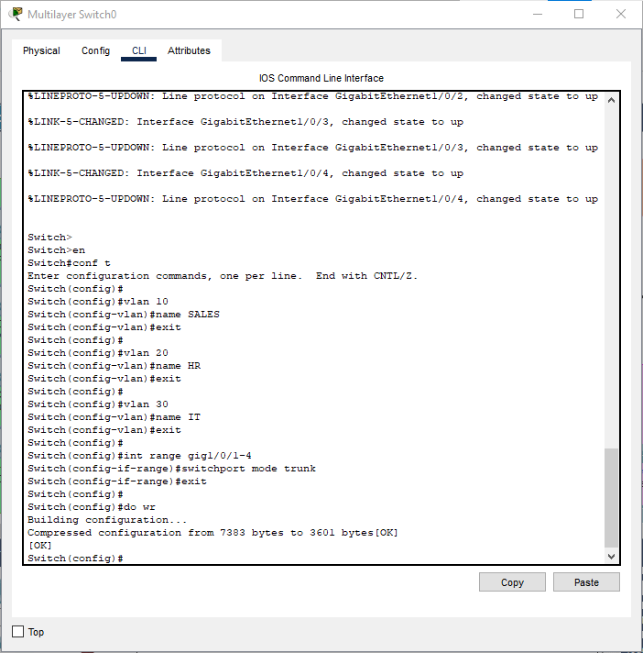

1. Trunking Between Multilayer Switch and Router



## Inter-VLAN Routing

1. Routing Configuration

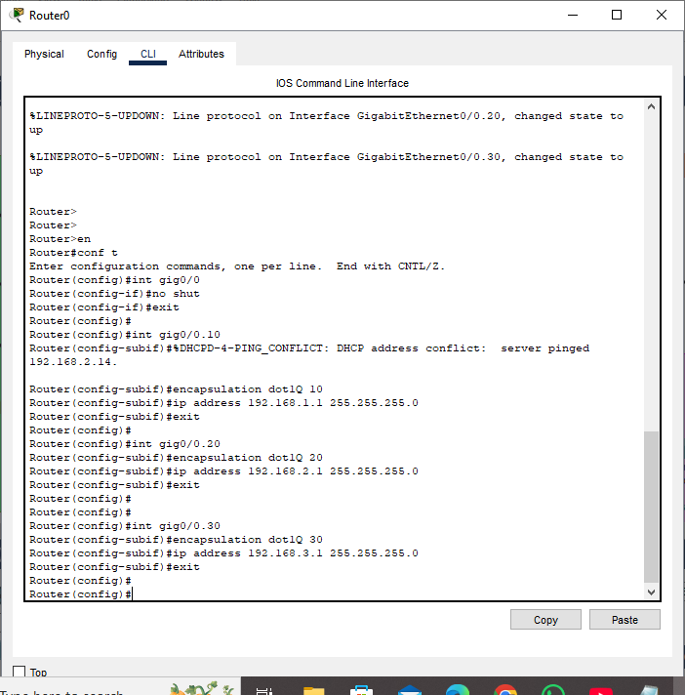

## DHCP Setup

1. Configure DHCP

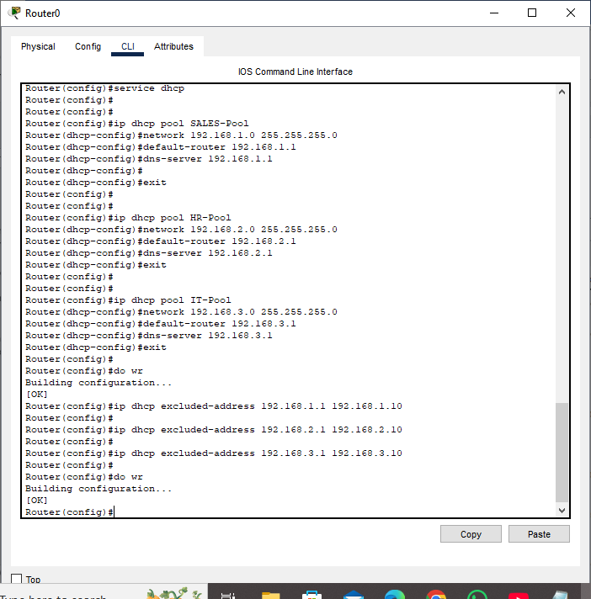



1. Assigning DHCP to VLAN

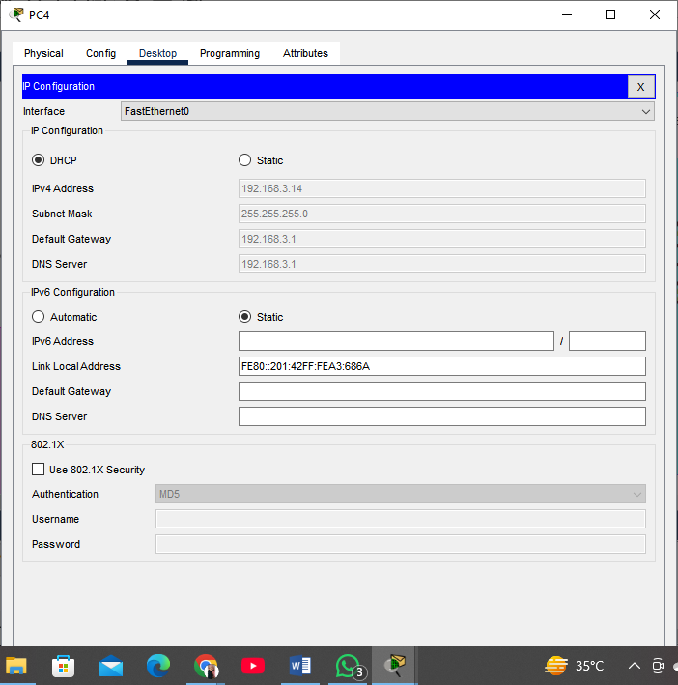

## Access Control Lists (ACLs) Setup

1. Block Access from HR to IT:

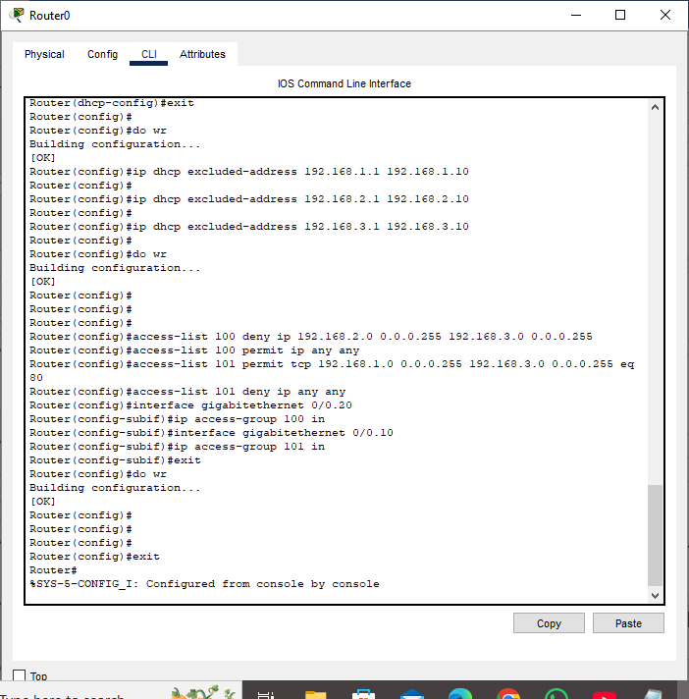

1. Allow Sales Limited Access to IT:



1. Apply ACLs to Interfaces:



## Wireless Network Setup

1. Wireless Access Point:

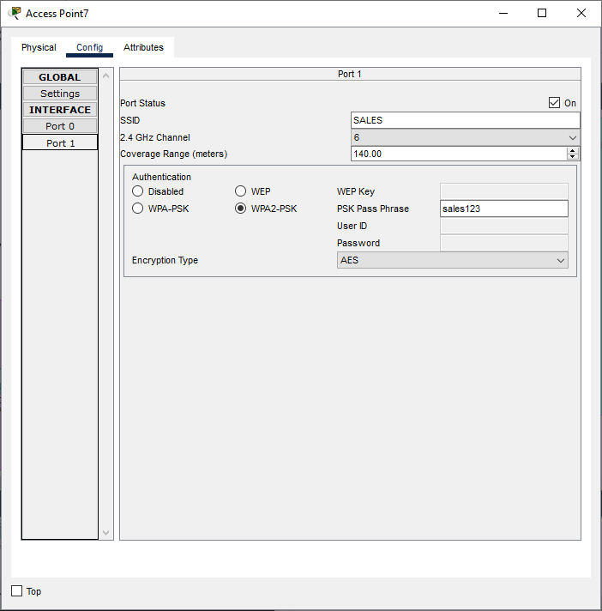

1. Wireless Device:

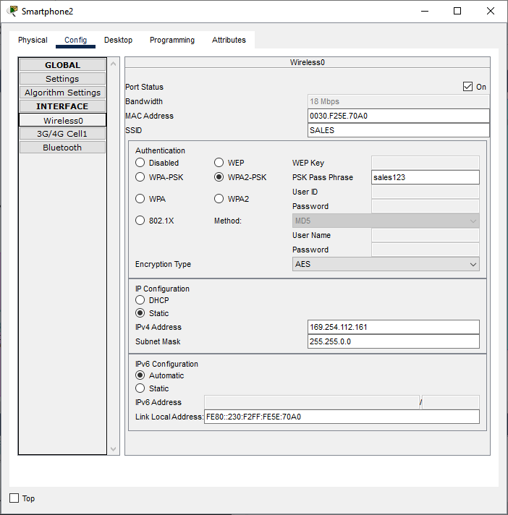

## PING (HR to IT):

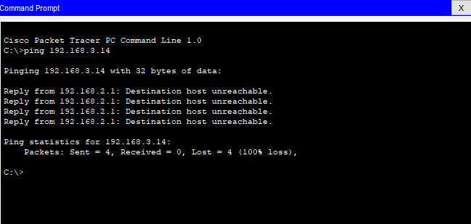

## PING (IT to HR):

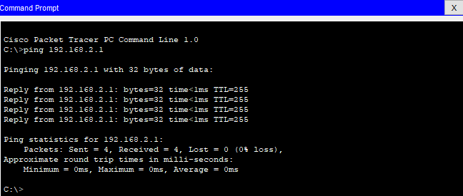

## PING (By Wireless):

